**Providing Excellence in Education and Care Since 1985**

18 Grafton Street, Shrewsbury, MA 01545

T: 508-842-0430 F: 508-842-1857 E: Info@LilliputSchool.com

W: www.LilliputSchool.com Facebook: LilliputSchool

Re-Registration for Current

1. As a parent, go to [MyProcare.com](http://myprocare.com/) and log in using the email address on file with Lilliput.
2. Once you’ve logged in:
   1. If registrations are available, you’ll see an alert. Choose *View*.  
      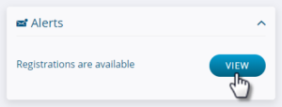
   2. Choose *Begin Re-registration*.  
      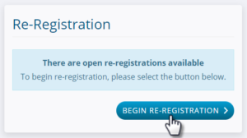
   3. Choose the first child you want to register and select *Next*. (If you do not see the child you’d like to register please contact the school. We will need their full name and date of birth to be added to your profile.  
      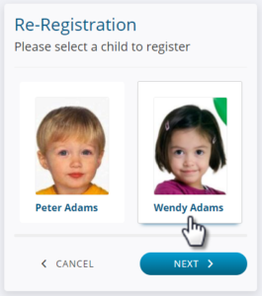
   4. Select one or more programs for the child by choosing *Register*, then *Next*.  
      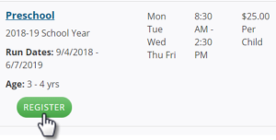
   5. Confirm the emergency contacts and authorized pickup people for the child and add any new ones by choosing *Add relationship* or use the red X to remove one.  
      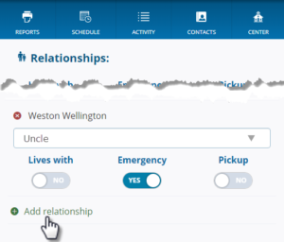
   6. Scroll to answer any child-specific questions and choose *Next*. the parent will see the existing answers (if any) and may make changes as needed.  
      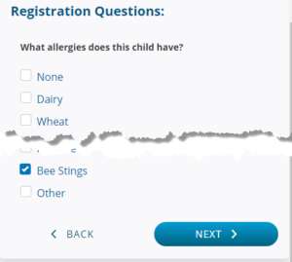
   7. If there is more than one child in the family, the parent has the option to register another child at the same time.

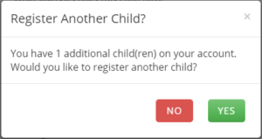

* 1. At the *Review* screen, the parent may add or remove programs or select another child, then press *Next*.  
     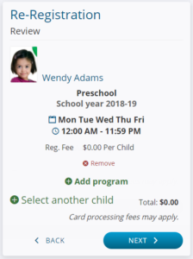
  2. If there are any account-level questions, those will appear next, then choose *Account Info*.  
     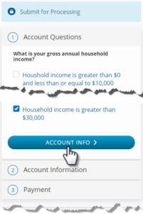
  3. The parent will have the option to make changes to their address or phone, if you chose that option when setting up the program choices.  
     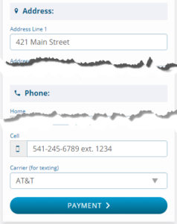
  4. If there is a fee for this program(s) choose *Payment*, enter the card information and select *Register & Pay*.  
     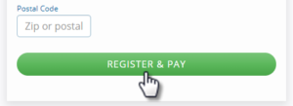  
     Hint: If there is no fee, simply choose *Submit*.
  5. The parent will see a confirmation / thank you screen.  
     